**SCHOOLS ALIVE**

Our School Choir are taking part in Schools Alive musical performance at the Blackpool Grand Theatre on Wednesday 7th February.

This is an amazing opportunity and we would like to wish our pupils taking part the best of luck and we hope they have a fantastic time!



**3B CLASS ASSEMBLY**

As part of their English topic Class 3B read the book ‘Stone Age Boy’ and presented their own stories and facts for their parent/carers who came to watch. Well done to all the pupils for their hard work.

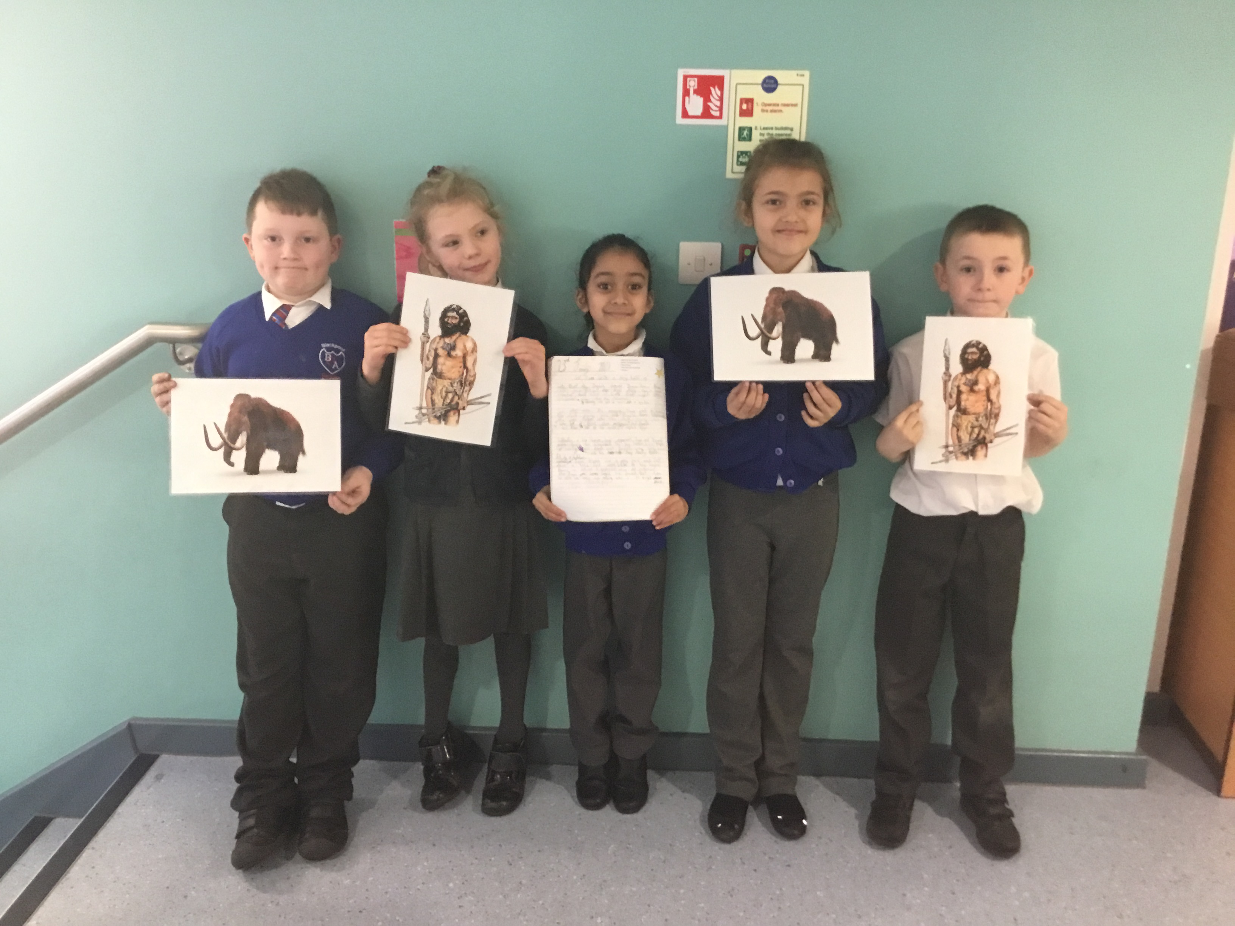

**PTFA’S**

**WEAR SOMETHING RED FOR VALENTINE’S DAY** 

**On the last day of term FRIDAY 9th FEBRUARY, we are asking pupils to come in an item of RED clothing, preferably a jumper, cardigan or t shirt, as the rest of the school uniform will still apply. Please bring a small donation of 50p to help towards the PTFA.**

**Your support is appreciated!**

**REMINDER**

Please make sure your child is in school on time. The gate closes at **0855**. It is **important** as your child’s attendance will be affected.

Also, please make sure your child has the correct uniform on, any issues please

speak to Mrs Riley.

*Family Support*



**WELCOME**

**NEW SCHOOL GOVERNORS**

We would like to announce our new school governors:

Salma Khatun

&

Sarah Broadbent

We wish them the best of luck in their new positions.

We would like to thank all those parents who took time to vote for our new school governors, your support is appreciated.

DATES FOR DIARY

**Wednesday 31st January –** Dan Worsley Author Visit

**Thursday 1st February –** 1G Class Assembly

**Friday 9th February - Monday 19th February - Spring Half Term**

**Tuesday 20th, Wednesday 21st, Thursday 22nd February –** Life Education Bus

**Thursday 22nd February –** Parents Evening

**Monday 26th February** – Year 4 Borwick Hall Trip

**Thursday 1st March –** World Book Day

**Wednesday 14th March –** 3G Class Assembly

**Thursday 15th March –** 1B Class Assembly

**Friday 23rd March – Monday 9th April** – Easter Holiday

**Principal’s Comment**

**We have had an action-packed half term and it does not seem to be slowing down!**

**Year 4s had a great time at Springfield Electricity Plant learning all about circuits and there are many more exciting enrichment trips planned over the Spring and Summer for all classes.**

**Nursery numbers are growing every day, please mention us to anyone who is looking for a nursery place for their 3 or 4 year olds. Open day flyers to follow.**

**A letter has gone out to parents of 1B to introduce our new class teacher, Mrs Tyrell, who will be starting with us after half term.**

**Thanks for all your ongoing support,**

**Mrs Gibbons**