On **FRIDAY 15TH DECEMBER** we will be taking part in **Save the Children's Christmas Jumper Day.**

Children are allowed to wear their Christmas jumper for a small donation. This is a worthy cause and we will be discussing how the funds collected go on to help children around the world. We look forward to seeing lots of **festive jumpers** in school on that day! The rest of **our uniform will still apply on the day.**

We have a very busy upcoming week leading up to our Christmas break. We would like to remind parents to collect their tickets from the office for the **Reception Carol Concert** and **Year 1 Nativity**, both on Tuesday 12th and Wednesday 13th December.

**Years 3 & 4** are preparing for their very own **carol concert** on Monday 18th December.

Our **School Choir** has got two extra special performances. A special **Blackpool Christmas Concert** at **The Blackpool Tower Ballroom** on Tuesday 12th December and a special visit to the **Royal Care Home** on Friday 15th December.



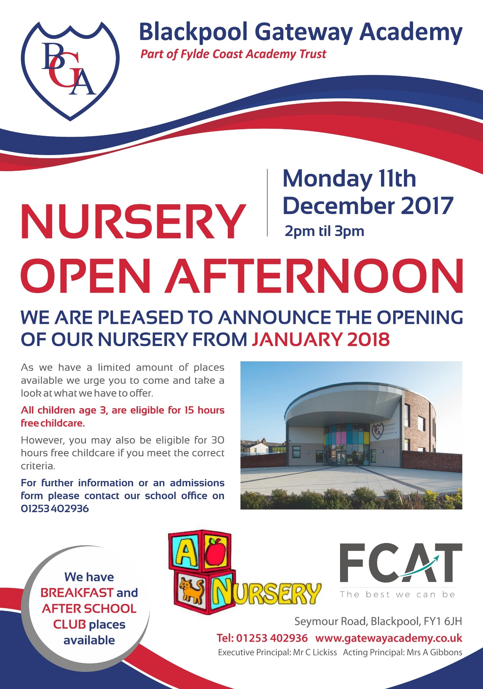

All the children and staff have been working very hard to produce some fantastic performances for you all. We would like to wish them all a very huge good luck!

**PTFA CHRISTMAS FAIR**

**Friday 15th December**

**3.15 pm – 5.00 pm**

**We would like to welcome you all . . .**

**Plenty of Christmas Craft & Gifts Stalls,**

**Raffle Prizes, Refreshments & Christmas Cheer!**

**PLEASE NOTE**

All Clubs will finish this term week commencing the 11th December.

We will be sending a letter out this evening regarding new clubs that will be taking place in the new year.

**REMINDER**

**There is No After School Club on Wednesday 20th December**

**A BIG THANK YOU TO**

**DEBBIE GODFREY-BROWN**

For taking the time to take this terms school photographs. Your help, hard work and generosity is much appreciated!

**HEALTHY LUNCH BOX**

**We would like to encourage all children to eat a Healthy, well balanced diet.**



**DATES FOR THE DIARY – 2018**

**Monday 8th January -** School Opens

**Wednesday 24th January –** 3B Class Assembly

**Wednesday 24th January** – 4B Springfields Trip

**Thursday 25th January** – 4G Springfields Trip

**Wednesday 31st January –** Dan Worsley Author Visit

**Thursday 1st February –** 1G Class Assembly

**Friday 9th February - Monday 19th February - Spring Half Term**

**Tuesday 20th, Wednesday 21st, Thursday 22nd February –** Life Education Bus

**Thursday 22nd February –** Parents Evening

**Monday 26th February** – Year 4 Borwick Hall Trip

**Thursday 1st March –** World Book Day

**Wednesday 14th March –** 3G Class Assembly

**Thursday 15th March –** 1B Class Assembly

**Friday 23rd March – Monday 9th April** – Easter Holiday

**\*\* WE NEED YOUR INPUT \*\***

**An Opportunity for Parent/Carers**

**MATHS & PHONICS courses with Blackpool Council Learn Together Programme**

**What courses would you like to study? Please Let our Office know.**

**Assistant Principal’s Comment**

The Christmas festivities are now getting underway and the school is a very busy and fun place to be!

We ask if you could please continue to have your children in school on time until we break up on Wednesday 20th December at 3.15.

We are looking forward to our Nursery Open Afternoon on Monday 11th December 2.00 -3.00 pm, we hope you are able to come along and support us.

From myself and all the Staff at BGA we wish you all a very . . .

**MERRY CHRISTMAS & A HAPPY NEW YEAR**

